TDA6323 Algorithm Design and Analysis

Lab 1 Mathematics Review & Basics of Algorithm Analysis

Theory:

Question 1
Refer to the Stable Matching Algorithms in your lecture note 1, consider the following ranked list between teachers (label as T1, T2, T3, T4, T5) and schools (label as S1, S2, S3, S4, S5). Illustrate the steps and sequence of how the algorithm will produce the perfect matched pairs from teacher to school. Unstable match occurs when: teacher A in the first matched prefers the given school X over his/her match pair and school X also prefers teacher A over its own match pair.

Teachers | Favorite |  |  | Least Favorite
T1 | S4 | S3 | S2 | S1
T2 | S2 | S1 | S3 | S4
T3 | S1 | S4 | S3 | S2
T4 | S1 | S3 | S2 | S4
T5 | S4 | S1 | S3 | S2

Schools | Favorite |  |  | Least Favorite
S1 | T2 | T1 | T4 | T3
S2 | T3 | T2 | T4 | T1
S3 | T4 | T1 | T2 | T3
S4 | T1 | T3 | T2 | T4
S5 | T2 | T3 | T4 | T1

Illustrate the match from school to teacher. Compare both results. What can you observe?

T propose to S:
If free à straight assign
If already match à check S and select best match available

Teacher Match: (T1,S4)(T2,S2)(T3,S3)(T4,S1) à Stable Match + T5 unmatched
Round 1
- T1 proposes to their 1st choice: S4. S4 is free and accepts. Pair: (T1, S4).
- T2 proposes to their 1st choice: S2. S2 is free and accepts. Pair: (T2, S2).
- T3 proposes to their 1st choice: S1. S1 is free and accepts. Pair: (T3, S1).
- T4 proposes to their 1st choice: S1. S1 is currently matched with T3. We check S1's preference list: S1 ranks T4 higher than T3. S1 rejects T3 and accepts T4. Pair: (T4, S1). T3 is now free. à (T3, S3)
Round 2:
- T3 (now free) proposes to their 2nd choice: S4. S4 is currently matched with T1. We check S4's preference list: S4 ranks T1 higher than T3. S4 rejects T3's proposal. T3 remains free.
Round 3:
- T3 proposes to their 3rd choice: S3. S3 is free and accepts. Pair: (T3, S3).
T5?
- T5 proposes down their list (S4, S1, S3, S2) , but because T5 is not ranked by any of the schools, T5 is rejected by all of them

School Match: (S1,T2)(S2,T3)(S3,T4)(S4,T1) S5 is unmatched

Result: Stable match while 5th participant in both remain unmatched

Question 2
Following are the questions related to arithmetic progression and geometric progression. Find T_{n} term.
- Arithmetic progression


  - $a=\sqrt{5},d=√5$ and n = 17.
$$\sqrt{5} + (17-1)\sqrt{5} = \sqrt{5} + (16)\sqrt{5} =17\sqrt{5}$$

  - $a=2+\sqrt{3},d=2-√3,$ and n = 20.
$$(2+\sqrt{3}) + 19(2-\sqrt{3}) = 2+\sqrt{3} + 38 - 19\sqrt{3} =(2+38) + (\sqrt{3} - 19\sqrt{3} ) = 40 - 18\sqrt{3}$$

- Geometric progression


  - $a=\sqrt{5},r=√3,$ and n = 17
$$5 ∙ {(\sqrt{3})}^{17-1} = 5 ∙ {(\sqrt{3})}^{16} = 5 ∙3^{8} = 32805$$

  - $a=2+\sqrt{3},r=2-√3,$ and n = 20.
$$(2+\sqrt{3}) ∙ {(2-\sqrt{3})}^{20-1} =$$

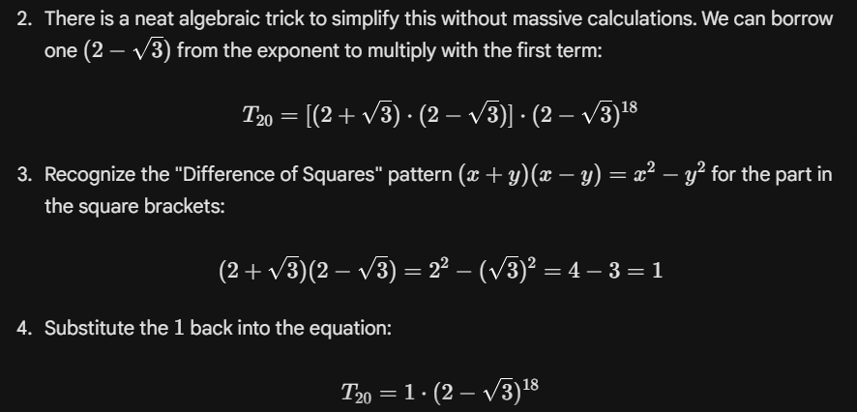


Question 3
Proof the formula by using induction.

- Using induction, show that $4^{n}+15n-1$ is divisible by 9 for all n>=1.

Base Case (n = 1):
Replace à $\frac{4^{1}+15(1)-1}{9}$ = 18/9 = 2 à is divisible by 9

$$4^{n}+15n-1$$

Inductive Hypothesis (n = k):
Replace à $\frac{4^{k}+15(k)-1}{9}$ = M à $4^{k}+15k-1$ = 9M

Can find $4^{k}=9M - 15k+1$

Inductive Step (n = k + 1):

$4^{k+1}+15(k+1)-1 = 9M$ à ${4∙4}^{k}+15k +15-1$ = 9M à ${4∙4}^{k}+15k +14 = 9M$

$4∙(9M - 15k+1)+15k +14 = 9M$ à 36M – 60k + 4 + 15k + 14

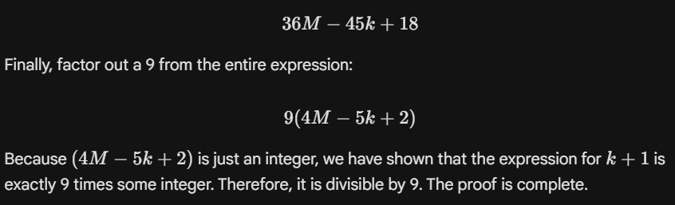

- Show that $n!<n^{n}$ for n > 1.

Question 4

Assume that you have the following computers: X, Y and Z. Each computer is having similar processing power where each computer can execute 5 billion instructions per second. However, each computer is running with different algorithm and the growth rate is different. Based on the information that you have, calculate the running time that is needed for each computer and sort the computers by using the execution time in ascending order.

Time = $\frac{Total n of instructions}{instructions per seconds}$

- Same instructions per seconds = 5 billion = 5 x 10⁹
- Different sorting algorithm (Growth rate) à n

Computer X | Computer Y | Computer Z
Running time grows by n | Running time grows by 2^n | Running time grows by n^(1/2)
Executes 5 billion instructions per second | Executes 5 billion instructions per second | Executes 5 billion instructions per second
Use n to sort n inputs | Use 2^n to sort n inputs | Use50(n)^(1/2) to sort n inputs
Time? | Time? | Time?

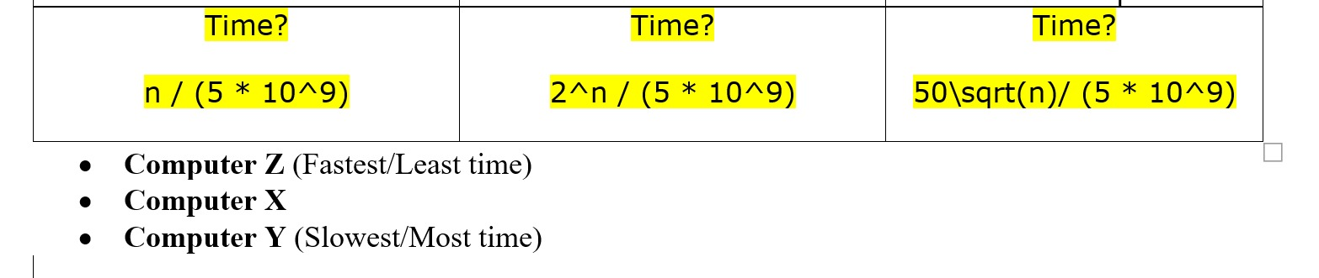

- 1s X
- Infinity Y
- 0.0007 Z

Z – X – Y

Question 5

partialSum(A,S,n) is an algorithm to find the partial sums of an array of n integers.

Algorithm partialSum (A,S,n)
Input: An array A storing n≥1 integers
Output: An array S storing the partial sums of A.
S[0] ß A[0]
for iß1 to n-1 do
S[i] ß A[0]
for jß1 to i do
S[i]ß S[i] + A[j]

- Based on the partialSum algorithm above, fill up the S[i] column in the table below.

i | A[i] | S[i] after the inner "for" loop executed
0 | 11 | 11
1 | 23 | 34(11+23)
2 | 5 | 39 (34+5)
3 | 27 | 66
4 | 33 | 99
5 | 1 | 100
6 | 45 | 145
7 | 18 | 163

- Count the number of primitive operations of each step in partialSum. What is the time complexity of partialSum?

Algorithm | Number of primitive operations
S[0] ß A[0] | 3 (2 access + 1 assign) | 3
for iß1 to n-1 do | 1+n (assign + n-1 + stop) | 1+n
S[i] ß A[0] | 3(n-1) | 3n-3
for jß1 to i do | (1 + n) (n-1) | n²-1
S[i] ß S[i] + A[j] | 5(n-1)(n-1) | 5n²-10n+5
T(n) | O(n²) | 6n²-6n+5
- The partialSum algorithm could be improved to O(n) complexity time. Write the improved arrayMax algorithm in the table below.

Algorithm | Number of primitive operations
S[0] ß A[0] | 3
for iß1 to n-1 do | 1+n (assign + n + stop)
S[i] ß S[i-1] + A[i] | 6(n-1)
T(n) | 7n -2 ≈ O(n)

Question 6

Identify the number of primitive operations of the following algorithm and provide the total running time.
Algorithm | #operations
for i ← 0 to (n-1) do | 1+n (assign + n-1 run loop + stop) | 1+n
a[j] = 0 | 2(n-1) (1 access + 1 assign) | 2n-2
for i ← 0 to (n-1) do | 1+n (assign + n-1 run loop + stop) | 1+n
for j ← 0 to (n-1) do | (n-1) (1+n) | n²-1
a[j] += a[j] + i * j | 6 (n-1) (n-1) | 6n² – 12n + 6
T(n) |  | 7n² - 8n + 5

O(n²)

Question 7

An old machine can run 10,000 basic operations in one hour. The maximum size for the problem to run in the new machine is 10 times faster, i.e. 100,000 basic operations in one hour. Based on the given growth rate equations, define the maximum size of input n for the old machine and n’ for the new machine with respect to each algorithm. [round the answer to floor for n and n’]

- Old machine = 10,000 operations per hour
- New machine = 100,000 operations per hour
- Growth rate = algorithm cost
- Need to find n = input size the machine can take considering operations per hour and growth rate

Growth rate f(n) | n | n’ | The Ratio of n’/n
10n | 1.000 | 10.000 | 10
20n | 500 | 5.000 | 10
2n² | 70 | 223 | 3.18
2^{n} | 13 | 16 | 1.23

- 10n = 10.000 à n = 1.000
10n’ = 100.000 à n’ = 10.000

- 20n = 10.000 à n = 500
20n’=100.000 à n’ = 5.000

- 2n²= 10.000 à n² = 5000 à n =$\sqrt{5000}$ = 70
2n²= 100.000 à n² = 50.000 à n’ = $\sqrt{5000} =$223

- 2^{n}= 10.000 à n = log(10.000) à n = 13
2^{n}= 100.000 à n = log(100.000) à n’ = 16

Linear algorithm, O(n), have higher ratio à better performance
Exponential algorithm à less performance

Quote of the day:
No one is perfect ~ That’s why pencils have erasers. ~ Wolfgang Riebe

